SUPPORTLYTICS
IT Support Team Performance Analytics

1.Executive Overview
Project summary. This project analyzes IT customer-support activity to understand ticket workload, issue complexity, resolution performance, customer satisfaction, regional behavior, escalation patterns, and relationships between support issues. The final evidence set contains five dashboard views covering executive, cluster, regional, recommendation, and resolution-time analysis.
11,409 | 5.52 | 120.6 h | 3.01 / 5
Total Tickets | Avg Complexity | Avg Resolution | Avg CSAT

Key observations
- The dashboard reports 11,409 tickets across seven regional categories.
- North America has the highest listed regional ticket volume at 1,947, followed by Africa at 1,924 and South America at 1,917.
- Europe records the highest displayed regional CSAT at 3.07/5, while Africa is lowest at 2.92/5.
- Average resolution time is 120.6 hours, providing the main service-performance benchmark in the dashboard.
- Major regions show escalation rates close to 48–51%, indicating an opportunity to investigate preventable escalation drivers.

2. Problem Statement
Large volumes of IT support tickets make it difficult to identify recurring issues, route tickets to suitable teams, monitor resolution performance, detect critical work, and understand regional patterns. The project converts ticket-level data into structured analytical views that support operational decisions

3. Objectives
- Clean and prepare the support-ticket dataset for analysis.
- Measure ticket distribution by category, priority, status, channel, customer segment, and region.
- Compare customer satisfaction, first-response time, resolution time, escalation, and SLA behavior.
- Create analytical features for routing, performance, geographic analysis, similarity, and clustering.
- Group similar tickets using K-Means and use similarity measures to support issue-pattern analysis.
- Present the results through mentor-ready dashboard visuals and actionable recommendations.

4. Dataset and Tools
Item | Details
Dataset | Kaggle customer_support_tickets_200k.csv
Size | Approximately 200,000 tickets
Processing | Python / Google Colab
Libraries | Pandas, NumPy, scikit-learn, Matplotlib, Seaborn, Plotly
Text analysis | TF-IDF and cosine-similarity-based analysis
Clustering | K-Means
Dashboard | Microsoft Power BI
Final dataset | cleaned_customer_support_tickets.csv

5. Main analytical fields
ticket_id, product, category, issue_description, priority, status, channel, region, previous_tickets, customer_satisfaction_score, first_response_time_hours, resolution_time_hours, ticket_created_date, ticket_resolved_date, escalated, sla_breached, operating_system, issue_complexity_score, customer_segment, Type, Resolution_Duration, Priority_Score, Queue, Latitude, Longitude, Cluster, Similarity_Score, Performance_Score.
The report uses the supplied project documentation for the field definitions and analytical workflow. The exact student source-code file was not present in the available attachments, so this document does not claim to reproduce the original code verbatim.

6.Preparation workflow
- Imported and explored the support-ticket dataset using Pandas.
- Checked schema, data types, missing values, dates, and numerical fields.
- Prepared date and numerical fields for aggregation and visualization.
- Created derived analytical fields for routing, performance, clustering, similarity, and geography.
- Mapped ticket categories to analytical types and support queues.
- Added latitude and longitude for regional analysis and geographic visualization.

7.Feature engineering
Engineered field | Purpose
Type | Classifies categories as Request, Problem, or Incident.
Queue | Maps categories to support teams such as Technical Support, Billing Support, Security Team, Development Team, Infrastructure Team, and Product Team.
Resolution_Duration | Represents time required to resolve a ticket.
Priority_Score | Converts ticket priority into a numerical analytical feature.
Similarity_Score | Supports comparison of similar issue descriptions.
Performance_Score | Supports performance comparisons.
Latitude / Longitude | Supports geographic visualization.

Analytical sequence
Data import → validation → cleaning → feature engineering → aggregation → visualization → dashboard assembly → insight generation.

8.Similarity analysis
Issue descriptions were represented numerically with TF-IDF. Similarity analysis was used to support comparison and grouping of related support issues. For large datasets, a full pairwise similarity matrix was avoided in favor of a more scalable vector-based approach.

9.K-Means clustering
- K-Means groups tickets with similar analytical characteristics.
- The documented feature set includes category, priority, resolution time, similarity score, and queue.
- The elbow method / WCSS is used to examine candidate cluster counts.
- Cluster size can be compared with resolution and performance measures.

10.Geographic analysis
- Regional coordinates are used to support geographic ticket distribution.
- Issue categories can be compared geographically and through category-by-region patterns.
- Regional workload is interpreted together with response, resolution, CSAT, escalation, and SLA measures.
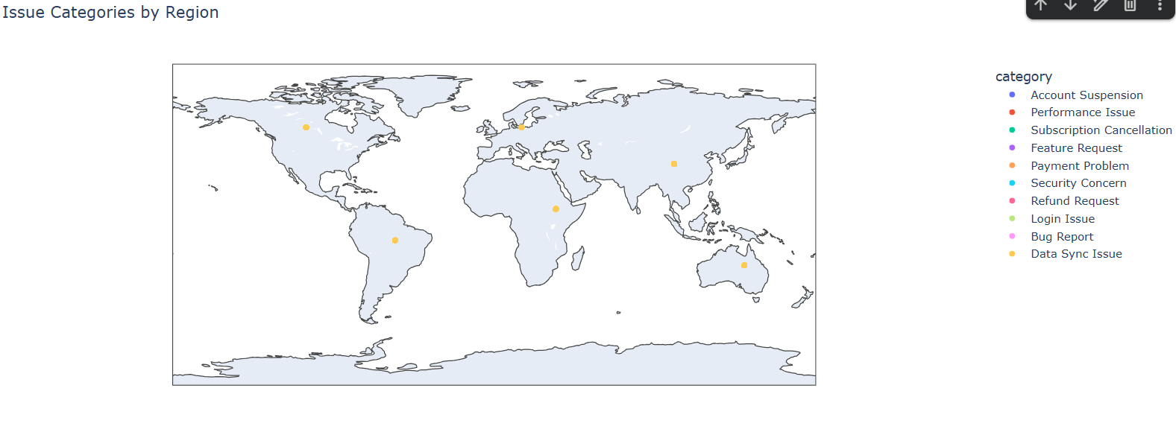

11.Implementation evidence
The documented implementation sequence is: import and inspect the dataset → validate fields → create engineered measures → apply TF-IDF similarity → apply K-Means and WCSS/elbow analysis → aggregate metrics by analytical dimensions → generate dashboard visuals → derive insights. The actual .py/.ipynb source file should be attached to the final mentor submission if exact code-level evidence is required.

12. DASHBOARD EVIDENCE — EXECUTIVE OVERVIEW
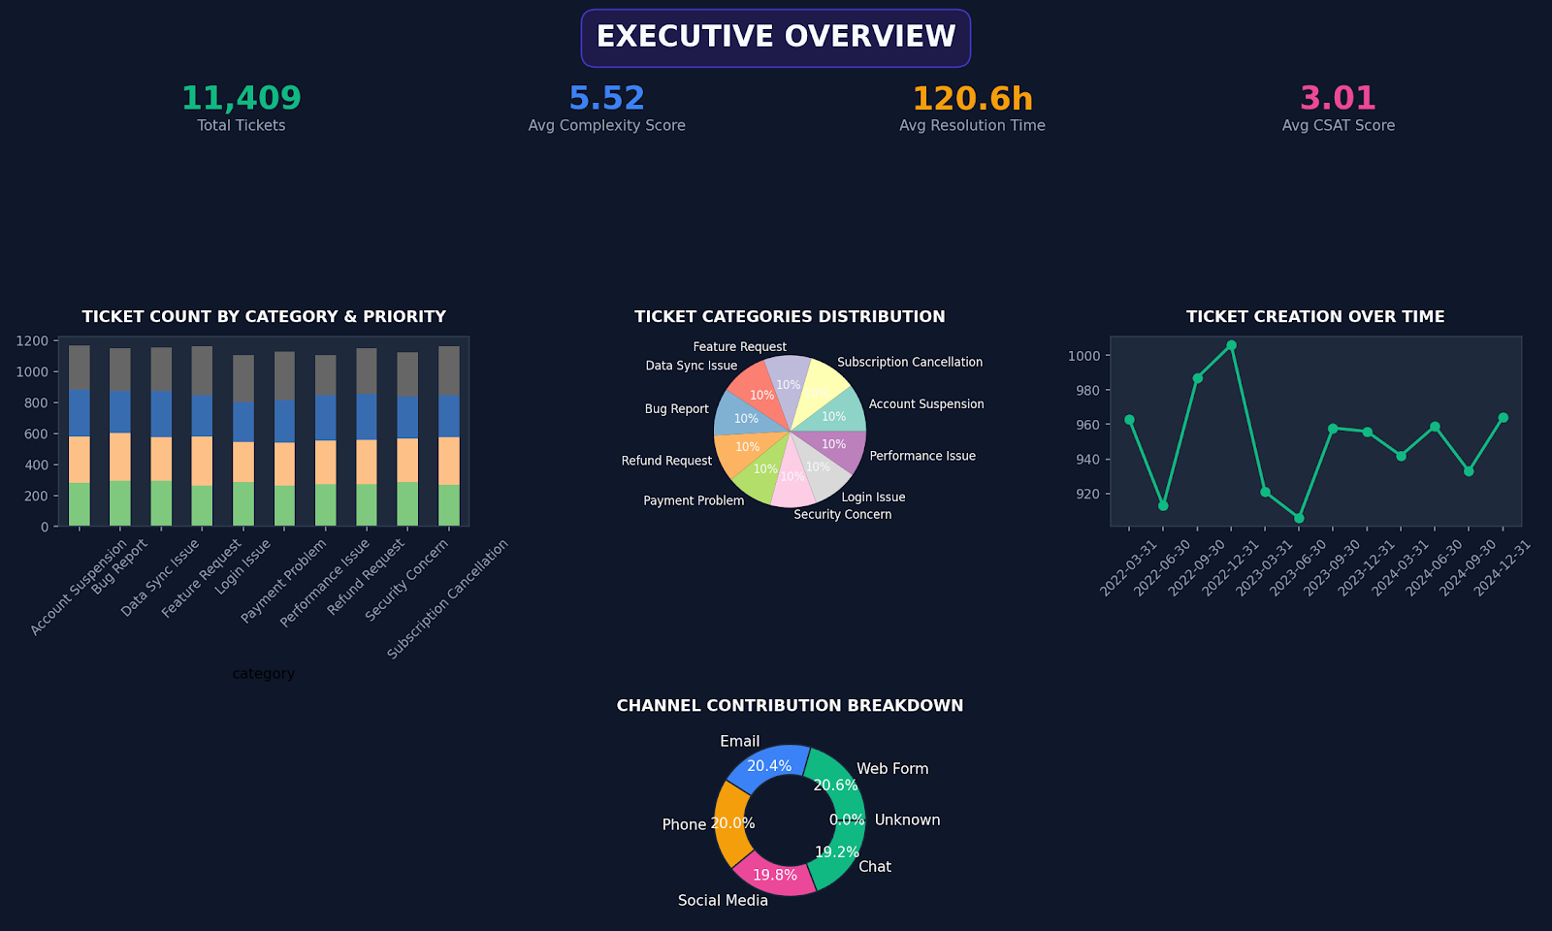

Interpretation
The executive dashboard provides the management-level starting point: headline KPIs, ticket volume by category and priority, ticket-category composition, ticket creation over time, and channel contribution. The 11,409-ticket workload and 120.6-hour average resolution time establish the overall operating context.

13. DASHBOARD EVIDENCE — RESOLUTION TIME ANALYSIS
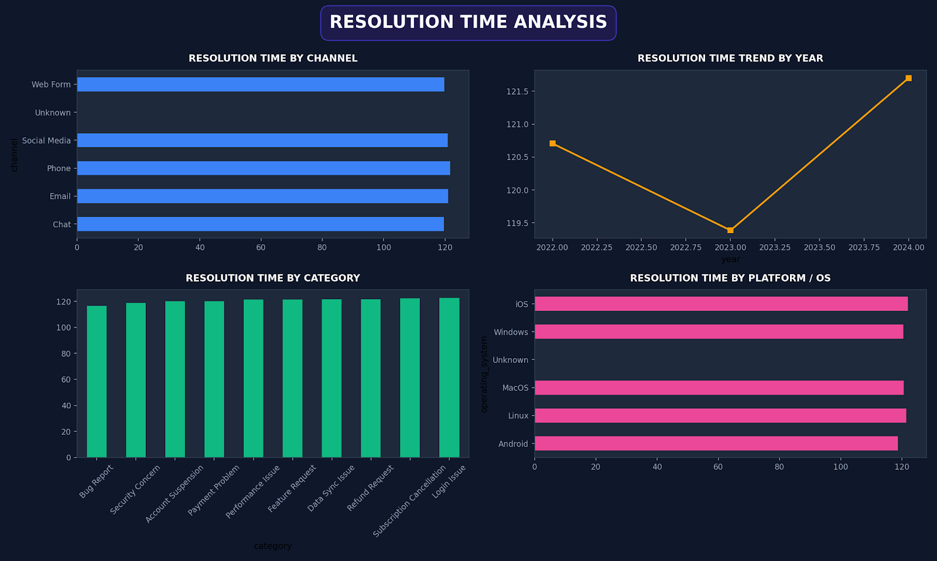

14. DASHBOARD EVIDENCE — CLUSTER SIMILARITY ANALYSIS
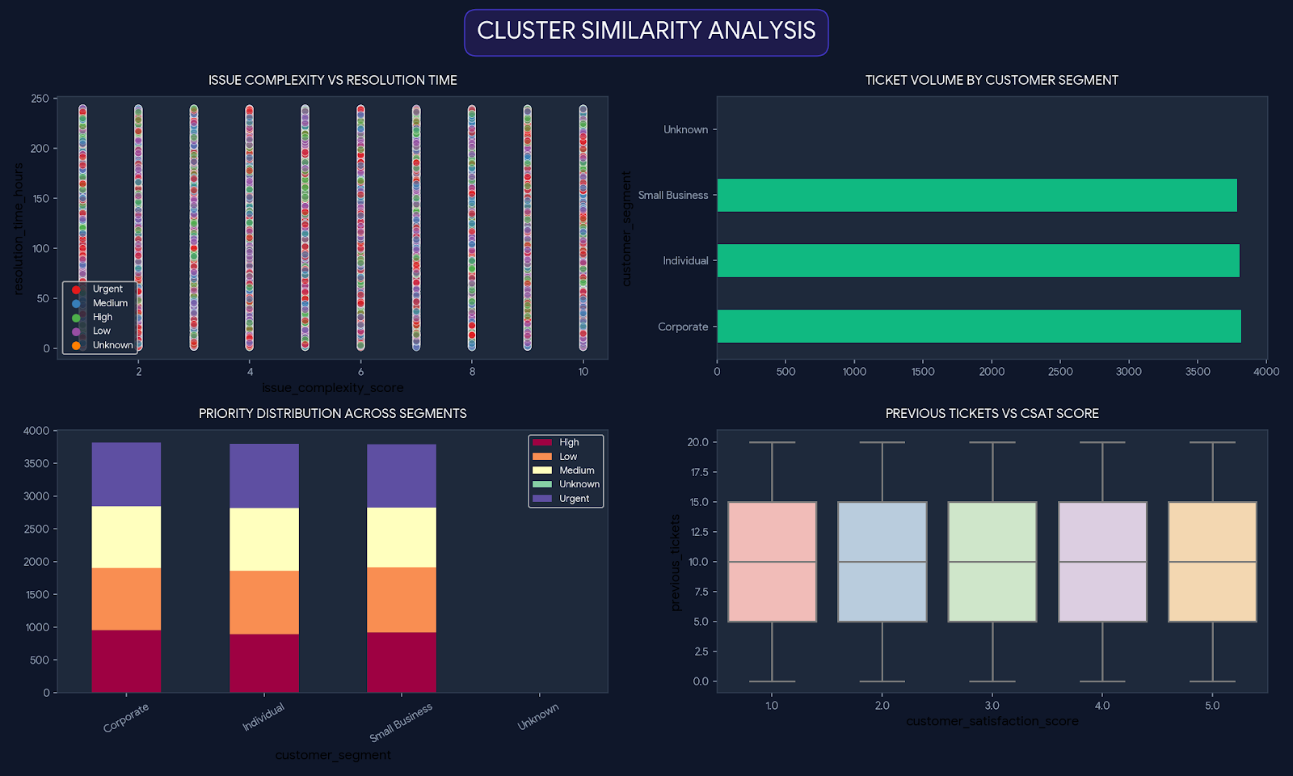

Interpretation
This view examines issue complexity against resolution time, customer-segment volume, priority distribution across segments, and previous tickets against CSAT. It is intended to identify issue patterns and relationships that may explain differences in support effort or customer experience.

15. DASHBOARD EVIDENCE — REGIONAL PERFORMANCE
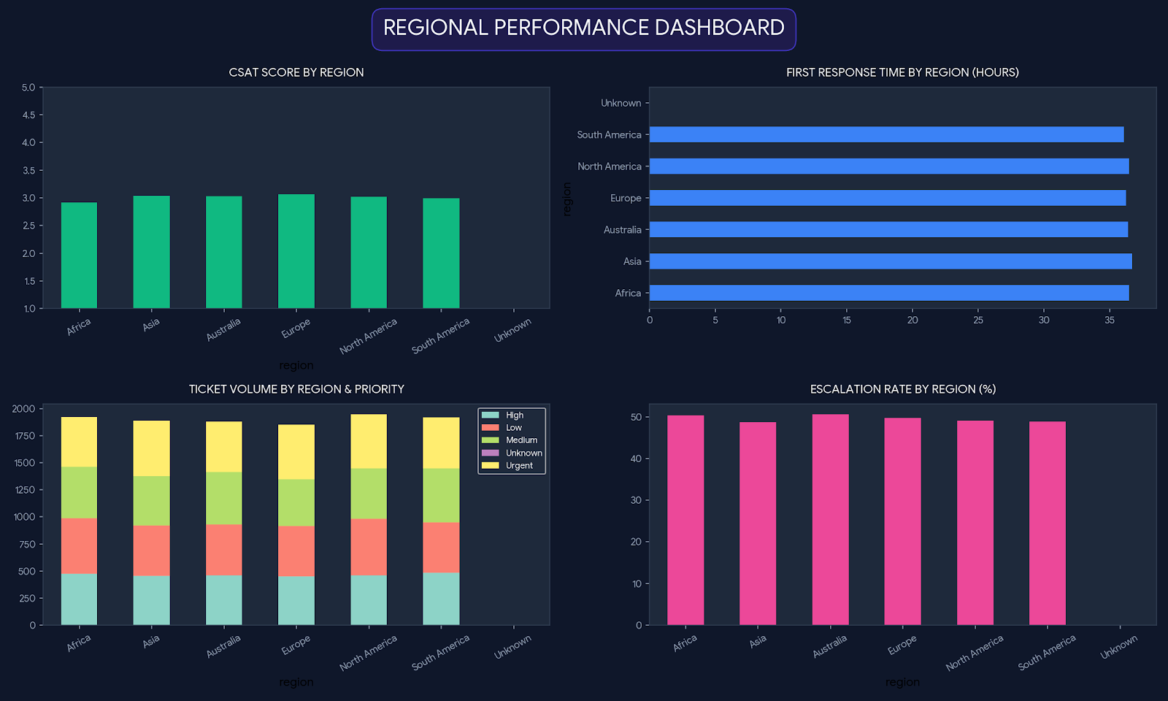

Interpretation
The regional view compares CSAT, first-response time, ticket volume by priority, and escalation rate. North America has the highest listed ticket volume, while Europe has the highest displayed CSAT. Escalation remains close to 50% across major regions, making escalation drivers an important area for further investigation.

16. DASHBOARD EVIDENCE — INSIGHTS & RECOMMENDATIONS
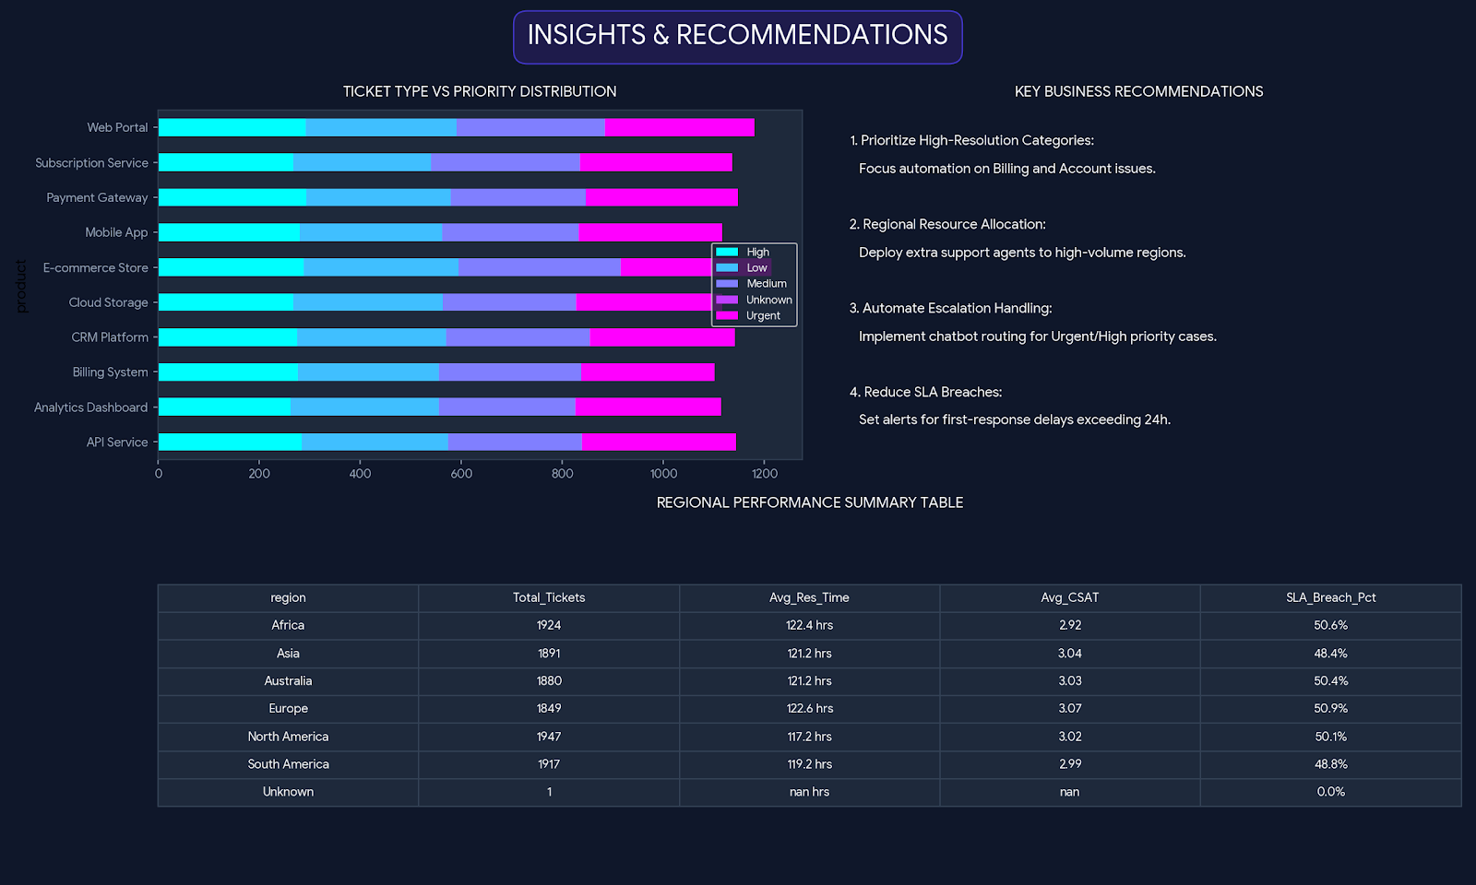

Key recommendations
- Prioritize high-resolution categories and focus workflow automation on billing/account-related work where applicable.
- Allocate regional support capacity using both ticket volume and first-response performance.
- Automate urgent/high-priority routing to appropriate queues.
- Investigate preventable escalations using category, first-response, and resolution-time patterns.
- Set monitoring around SLA and response-time delays and use the dashboard as a recurring management review.

17.Visual findings
- Average resolution time is 120.6 hours, with relatively close values across the displayed channels, categories, and operating systems.
- The year trend shows movement across 2022–2024, indicating that resolution performance should be monitored over time rather than as a single KPI.
- Category-level resolution times are broadly grouped around the overall average, with some categories slightly higher or lower.
- The dashboard supports comparison of operational performance by channel, category, year, and platform/OS.

18.Project Deliverables
- Cleaned Dataset
- Data Analysis
- Data Visualization
- Customer Support Dashboard
- Cluster Similarity Analysis
- Regional Performance Analysis
- Resolution Time Analysis
- Insights & Recommendations
- Python/Jupyter Notebook
- Project Documentation
- Final Project Report

19.Conclusion
The Supportlytics project converts support-ticket data into a structured decision-support solution combining workload monitoring, customer satisfaction, regional performance, escalation behavior, priority analysis, resolution-time analysis, and issue-similarity/clustering views. Together, the dashboards provide a clear basis for identifying operational bottlenecks, allocating support resources, and improving customer experience.
Submission note: attach the original dataset, Power BI workbook, and the actual Python/Jupyter source file used in the project when submitting the final mentor package. This keeps the documentation fully traceable to the implementation.

